Supported by the United Way of Leeds and Grenville
2021 Annual Report

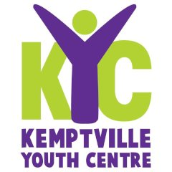
Rolston Hall,5 Oxford St. West,
Box 1124
Kemptville, ON K0G 1J0
T. 613-258-5212
VISIT: www.kyc.team
Charitable Organization 88830029ORRR0001v

MESSAGE FROM OUR PRESIDENT
Since its’ early beginning as THE UNDERGROUND KYC has been a safe, friendly haven for youth to drop in after school and in the evenings. KYC has an amazing team of staff, board members and volunteers who bring diversity and enthusiasm to our Centre coupled with a great group of youth that participate regularly in Centre activities.

It was a year overshadowed by COVID. We followed Leeds & Grenville Health instructions throughout the year, closing in March and then re-opening following PPE guidelines and initiating strict cleaning procedures.

Our Manager Barb Tobin and our Program Coordinator Micaela Comerford had a challenging year. Despite COVID we have maintained solid contact with youth through social media – something we will wish to continue.

Our fundraising activities where initially impacted, and we obtained support from the
Federal Got and notably from the United Way of Leeds & Grenville. Our Book Fair and Golf events were again successful.

A huge thank you to Jennifer Franssen and
Graham Pincott who retired from the BOD
in 2021. Both made considerable contributions
to KYC over the last 10 years. Jennifer has moved to
to Alberta while Graham remains as the KYC
Accountant.

Bruce Wehlau, President, 2021

2021 Board of Directors

Bruce Wehlau, President
Helen Pethick, Vice-President
Graham Pincott, Treasurer
Carolyn Hardie, Secretary
Missy Henshall
Brian Arleth
Ryan Hodgins
Claude Smith
Jennifer Franssen, Past President

Manager
Barb Tobin is our Operations Manager. Barb joined KYC on a part time basis in January 2019. Barb brings 30 years of high school teaching experience, 12 years as a North Grenville Councillor as well as skilled and talent in graphic design & marketing.

Program Coordinator
Micaela Comerford was our 2019 Summer Assistant Program Coordinator and became Program Coordinator in December 2019. She is completing her studies in Education with majors in English and French. She is an avid horse person and has introduce youth to her passion at the Turnout Stables. Her help with social media in 2020 was immense.

Some thoughts from our Manager Barb …

In 2021 the Kemptville Youth Centre continued to provide a safe and inviting environment for community youth. The youth were actively involved in regular programming. With COVID restrictions we continued daily activities through our social media accounts. Our Program Coordinator. Micaela, continued to offer activities to promote mental and physical wellness. We also were fortunate to have a CO-OP placement student from Algonquin College to help on the floor with youth. We also benefited from the Canada Summer Works Program that allowed us to hire an assistant coordinator for eight weeks. We continue to see growing numbers daily and popular programs include the Snack Shack, Baking and Cooking, , Gaming. and Sports. We continue to emphasize that the success of keeping the Centre open is a team effort. Our volunteer base keeps the Centre alive. Our partnerships in the community are an important resource. The community has again stepped up to support our community youth. Continuing to keep youth engaged and feeling that they are valuable community members will be a focus as we move into 2022.

Positive minds, Positive Vibes, Positive Life!

Positive Minds, Positive Vibes, Positive Life!

Did you know …
KYC provides an E-Waste recycling program to our community.
In 2021 we were able to divert over 50,000 kilos. of material from our local landfill site.
Our collection of bottles and cans from the North Grenville Landfill and surrendered to the Beer Store yielded $2,167
Great job North Grenville and thanks for supporting KYC and the environment!

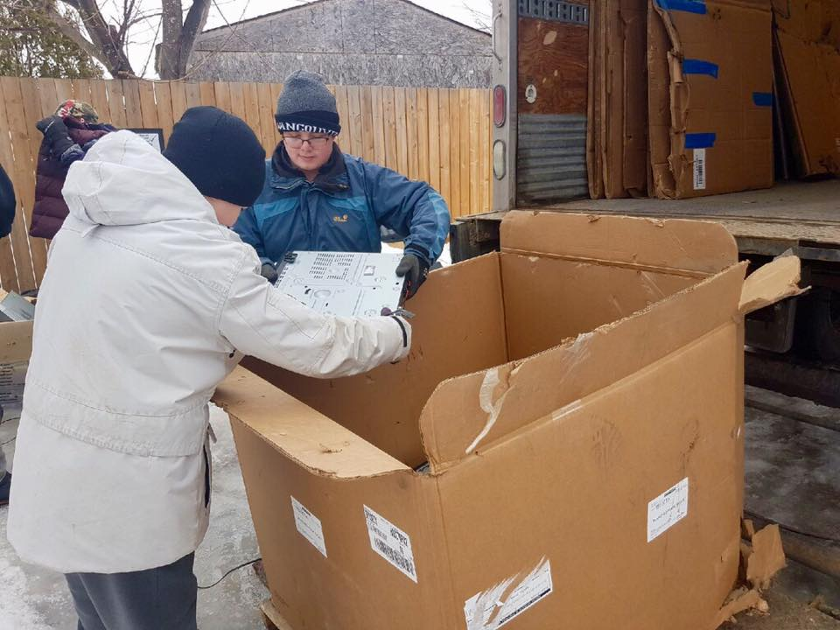
Thanks to the generosity of Jansen Law KYC benefitted from a donation of slightly used computers that have updated our technological ability and offerings for our youth!.
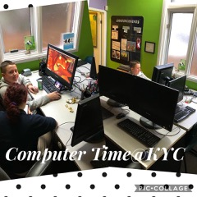

Our Report Card - How are we doing?

Our 2021 priorities included ….

- Membership - KYC will maintain youth participation /attendance at Centre and increasing numbers by two new members per month.

We are pleased to report that our monthly stats continued to grow throughout the year and there were several new youth joining the fun! On average we see 15 regulars a day (3-5 days) but numbers vary depending on activities and time of year.

- Community - KYC will increase the number of community partnerships by one per quarter.

KYC: Despite COVID we maintained our connections

- Programming – Reviewed Programs by assessing current KYC offerings, identification of opportunities and modification of existing program as required. Strengthening of social media use.

- Administration – We reviewed and revised, where necessary, our Operations and Treasurers Policy Manual.
KYC IT resources were reviewed, recommendations are being considered.
The process of renewing of KYC web page was commenced with a view to updating it and make it more mobile friendly.

- Building - Maintenance and Improvements Plan reviewed & updated.

Finances and Fundraising - Find more ways to be self-sustainable, be it through long-term pledges, identification and approval for new grants, program cost recovery, and/or increased fundraising.

Raised funds for new flooring, renovations to the lobby and back entrance completed and leaking
problem from back lot corrected.

We worked with an event planning organization to assist in development of a new fundraising event for the Fall of 2020 – COVID has postponed this!

In 2021 we commenced work on installing a basketball facility at the rear of the building.
It will be about a third the size of a full court with one hoop – the hoop has been installed and initial base material donated by COCO and laid by volunteers with help and equipment from First Stop Rentals.
We hope to finish the surface and mark the court in 2022.

.

FUNDING & SUSTAINABILITY

KYC cannot function without ongoing funding from such organizations such as The United Way, Ross McNeil Foundation, Canadian Tire Jumpstart, Nutrition for Kids (N4K), House of Lazarus just to mention a few.

At the same time, we rely on our fundraising efforts which, in 2021 included:

- KYC Golf Tournament at Rideau Glenn
- Annual Book Fair at the
Ferguson Forest Centre
- Bottle Drive from the NG Municipal Landfill to the Beer Store
- In collaboration with the NG Municipality, the E-Waste collection

KYC also receives numerous donations from all corners of the community.

KYC uses any surplus in fundraising and grants to provide both a 6-month Operations Reserve and a Capital Reserve to ensure that there are funds available for emergencies – such as COVID!!

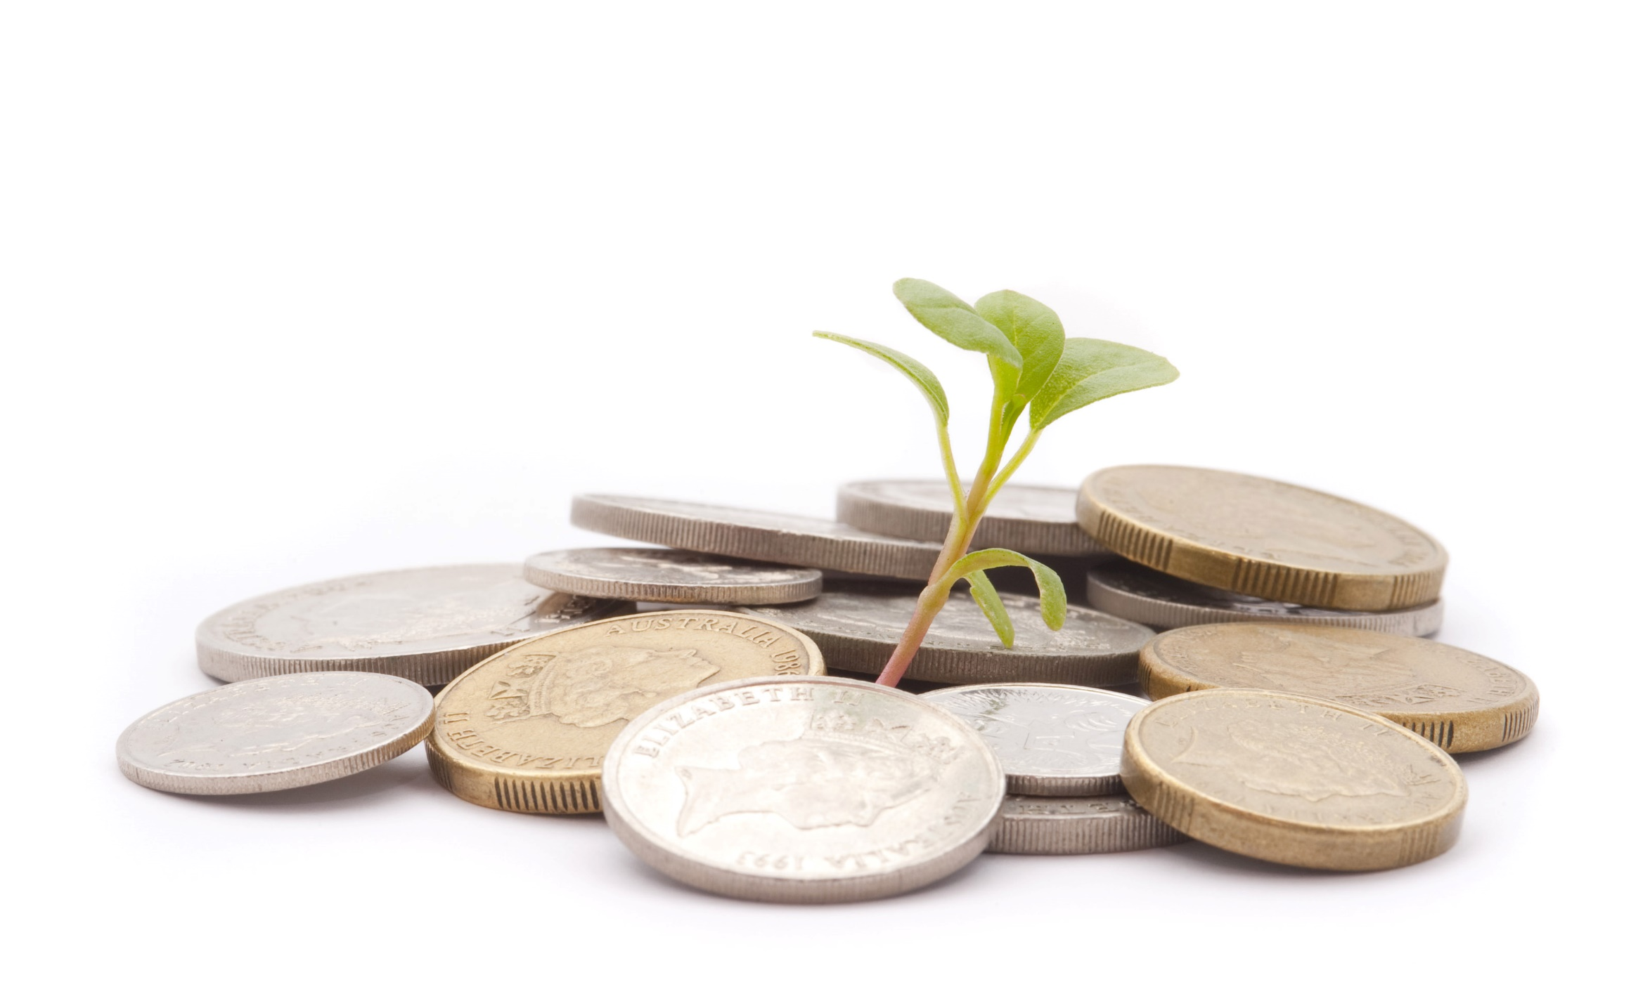

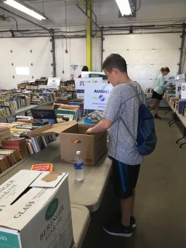
Books, books and more books!
Youth volunteered during sorting, set up, sale and cleanup.
A very successful fundraiser!

2020 Golf Tournament
KYCs’ 4some had a great time!
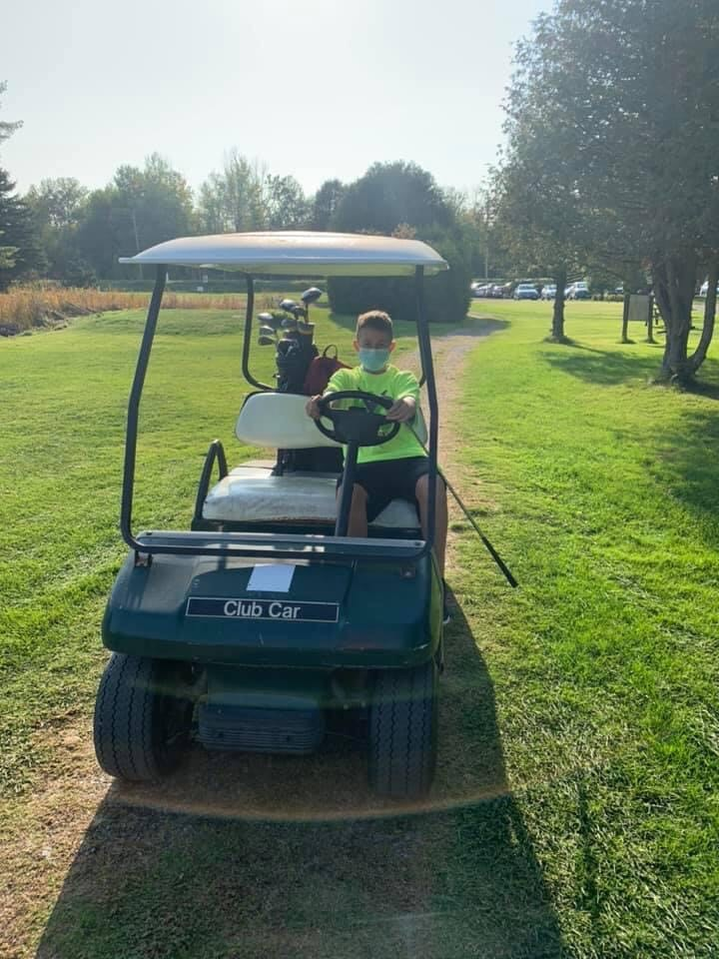

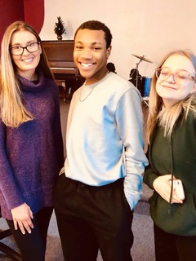

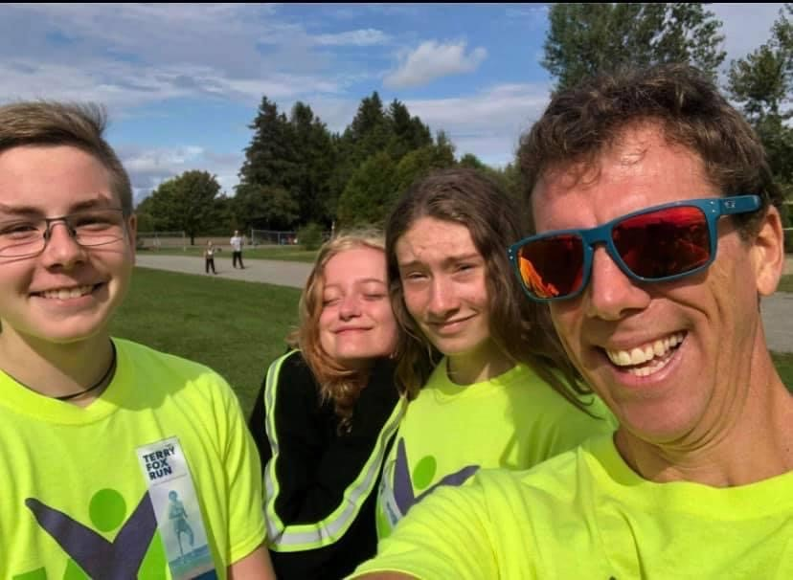
In 2021 KYC offered local youth …
Daily After School Drop-In & Homework Help offered Every Day!
Daily Fun Programs include:
Bake/Cooking Events – Sports Activities – Movie & Arts Activities
Games: Pool – Ping Pong -Board & Computer Games - weekly “Dungeons & Dragons”

+ lots of different events, activities and field trips!

With COVID we increasingly stepped outdoors to be healthy and active!!
Forever health conscious - our Sports are a hit!
.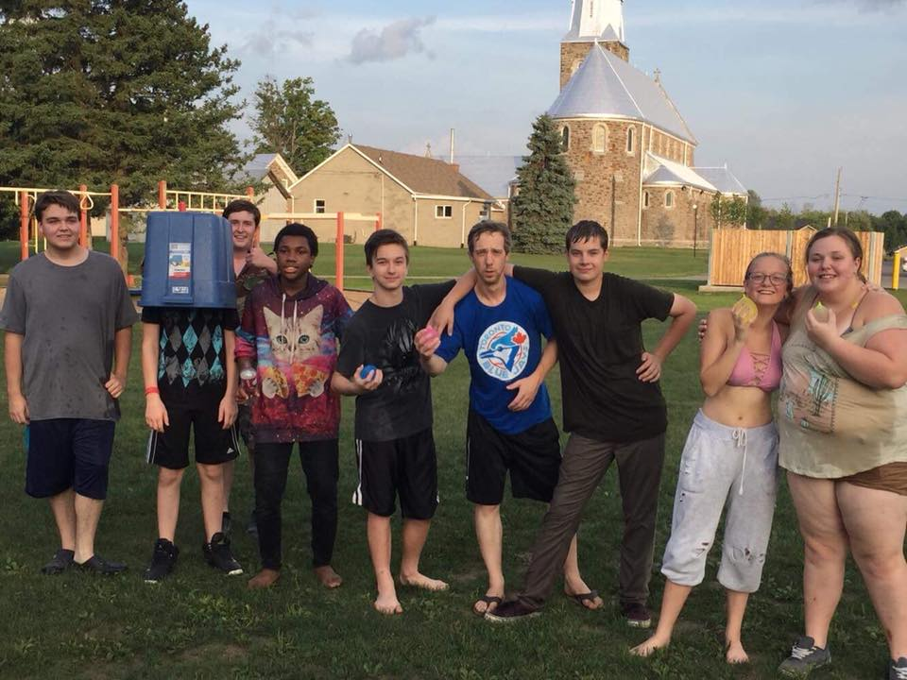

KYC is fortunate to have the support of the Catholic School District, Canadian Tire Jumpstart and our regular Volunteer Ryan as key element of our Sports Programming.

Healthy Cooking and Baking
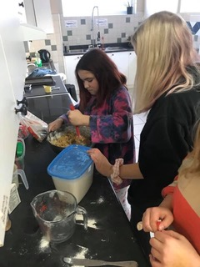

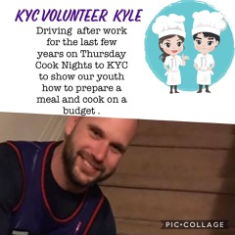

Jumpstart also makes excursions throughout the region a possibility for everyone!

COVID prevented us from mounting our popular excursions in 2021 but once it is possible we will resume them!!

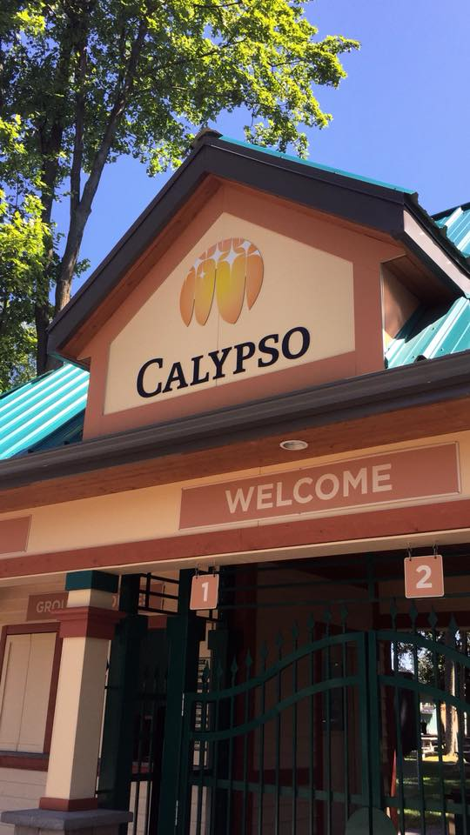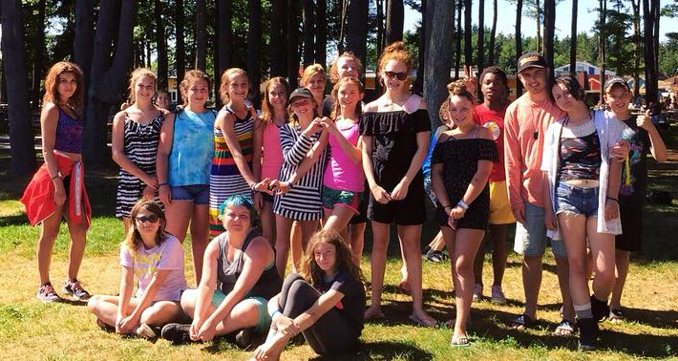
This Favourite Summer Excursion
Would not be possible without our enthusiastic volunteers!
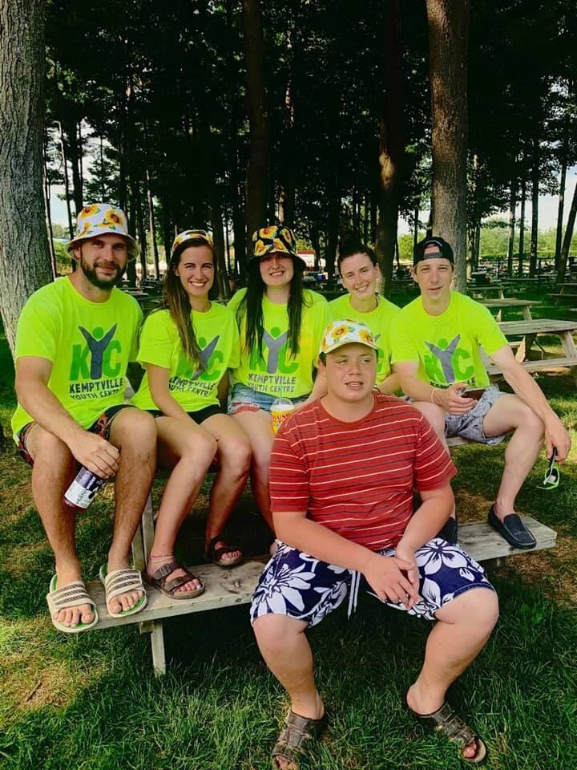

FINANCIAL OVERVIEW

The Kemptville Youth Centre has a qualified volunteer accountant managing its books which are audited annually. Monthly financial reporting to the Board ensures that KYC does not operate in a deficit and maintains its contingency reserves.

The 2021 Financial Position saw an increase in cash balances due to the support of the Government of Canada, Community Organizations, and generous individuals in the community to ensure that services can continue to be offered during the Pandemic through to the end of 2021.

KYC received $17,000 from Wage Subsidy program along with $7,000 in Federal grants distributed through the United Way. At the same time gifts and grants were received from 100 Women Who Care, Kemptville Quilters Guild, Canadian Tire, Grenville Mutual, Lions Club, RBC, WalMart and The Municipality of North Grenville.

Brian Arleth
Treasurer

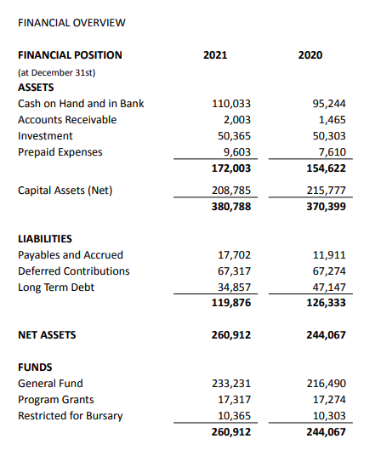
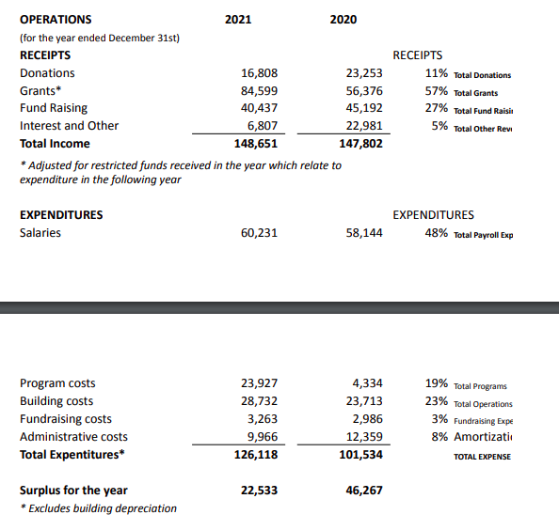
NOTE: Financial Statements have been audited by Walker & Associates

